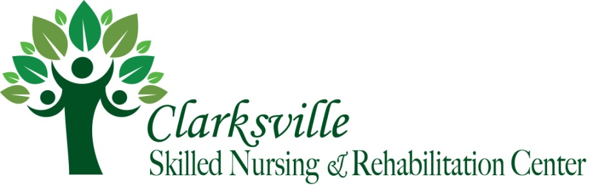
Original Post under our Blog on 08/01/2021 at 8:25am
To enhance efforts to keep COVID-19 from entering and spreading through nursing homes, facilities are required to test residents and staff based on parameters and a frequency set forth by the Health and Human Services Secretary. Facilities can meet the testing requirements through the use of rapid point-of-care (POC) diagnostic testing devices or through an arrangement with an offsite laboratory. Starting September of 2020, nursing homes are required to test staff as defined by CMS on a frequency basis ranging from once a month and up to twice a week. As stated in previous communications and notification, increase testing will assist in identifying asymptomatic individuals who have the potential to test positive.

On July 31st,2021, one staff member tested positive with the use of our rapid COVID-19 antigen test; this individual was symptomatic of COVID-19. This individual will remain out of the building and remain in self-isolation. Lastly, this individual will not return to work until released from the Public Health Department.

All residents who agreed to testing were NEGATIVE.

As defined by CMS, we will continue to following their guidance as outlined below:
CMS Definition of Outbreak Status
An “outbreak” as “any new case” that arises in a facility is defined as a new COVID-19 infection in any healthcare personnel or any nursing home-onset COVID-19 infection in a resident. Subsequent testing of all staff and residents that have tested negative must continue every 3-7 days until testing identifies no new cases of COVID-19 among staff or residents for a period of at least 14 days since the most recent positive result.

Thank you for your patience and support during these past several months, as we have all worked together to safely navigate the COVID-19 pandemic. This continues to be a very difficult time for everyone. We will continue to provide you with updates via our facility website at (www.clarksvilleskilednursing.com) located under the Newsletter/COVID19 tab.

Additional Links and Resources:
Frequently Asked Question: Frequently Asked Questions about COVID-19 Vaccination | CDC
Vaccine Resource: Vaccines.gov - Find COVID-19 vaccine locations near you
Safety and Monitoring: Ensuring COVID-19 Vaccine Safety in the US | CDC

Continuing Core Principles of COVID-19 Infection Prevention at our Center include:
• Screening of all who enter the facility for signs and symptoms of COVID-19 (e.g., temperature checks, questions or observations about signs or symptoms), and denial of entry of those with signs or symptoms.
• Hand hygiene (use of alcohol-based hand rub is preferred).
• Face covering or mask (covering mouth and nose).
• Social distancing at least six feet between persons.
• Instructional signage throughout the facility and proper visitor education on COVID19 signs and symptoms, infection control precautions, other applicable facility practices (e.g., use of face covering or mask, specified entries, exits and routes to designated areas, hand hygiene).
• Cleaning & disinfecting high frequency touched surfaces in the facility often, & designated visitation areas after each visit.
• Appropriate staff use of Personal Protective Equipment (PPE).
• Effective cohorting of residents (e.g., separate areas dedicated COVID-19 care).
• Resident and staff testing conducted as required.
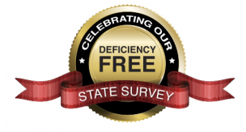

Caring for Those You Care About,
Clarksville Skilled Nursing and Rehabilitation Center

